June 19-24

**Important Economic Events**

By Nicolas Awlime

20 June - China cuts its benchmark rates. China cuts its 1-year and 5-year lending rates by 10 basis points to 3.55% and 4.20% respectively. This is the first cut in 10 months and should help the economy to recover from the zero covid plan, which weakened demand.

20 June - US housing. Housing starts rose sharply in May, with 1.63 million new homes built. These data run counter to the expectations of most economists, who are forecasting a recession in the US economy in the months ahead.

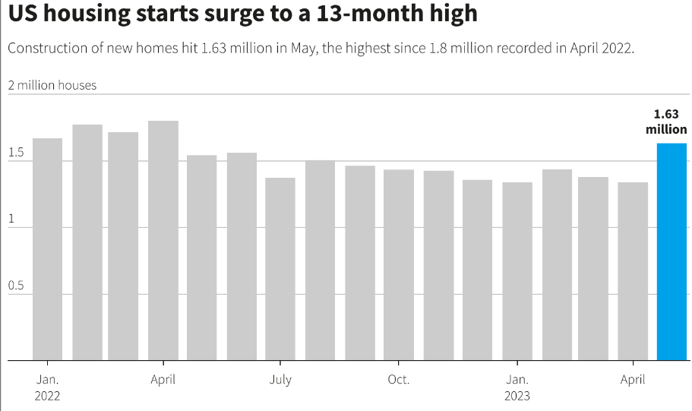

21 June - Inflation problem in the UK. Core inflation reaches 7.1%, its highest level since 1992. The UK is the world's third largest net importer of food and drink. In addition, the UK is experiencing a shortage of staff with the end of free movement of workers from EU countries. The market is forecasting further increases in borrowing costs over the coming months to combat inflation.

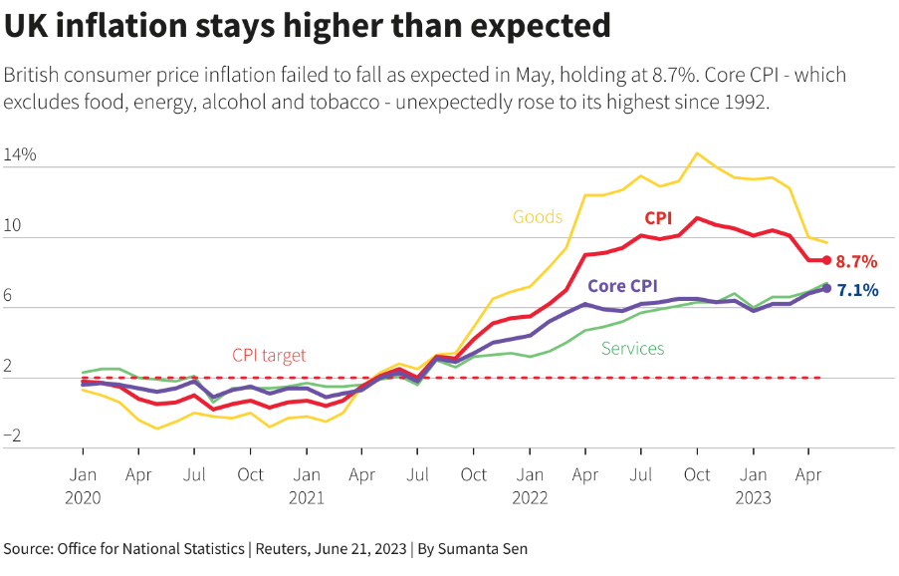

22 June - The BoE raises rates to 5%. To control persistent inflation, the BoE is raising rates to 5% by 50 basis points, 25 basis points more than expected. The BoE has decided to fight inflation more fiercely as the latest economic indicators suggest that it may take longer to bring down the current high inflation.

